Team_D_Receiving

# **ERD for UX process**

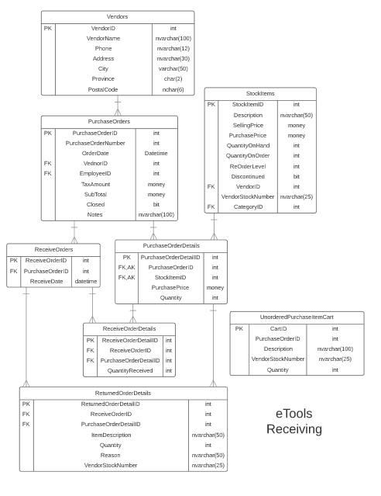

# **Possible UX Interface**

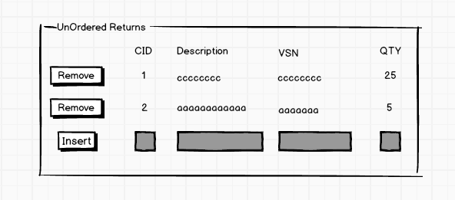

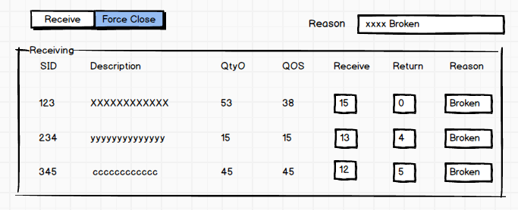

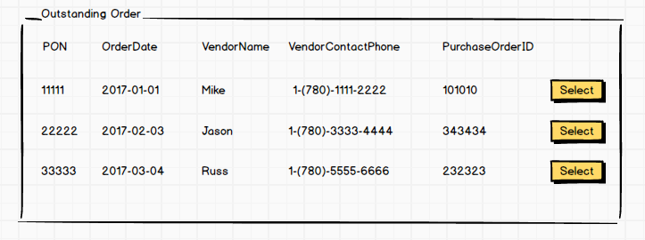

**Possible UX processing plan**

|  |  |  |
| --- | --- | --- |
| **Controls** | | **Events** |
| SelectOrders (Purchase Orders ),  PurchaseOrderDetails, PurchaseOrderDetailsBy, PurchaseOrderId | | OnClick / wired via ObjectDataSource   * Move selection value to PurchaseOrderDetailsBy * Bind data to Purchase Order |
| **BBL Class(es) and Method (s)** | | |
| PurchaseOrderController | List<PurchaseOrderList> List_PurchaseOrderForReceiveOrdersSelection(int PurchaseOrderId)   * Retrieve a list of PurchaseOrderDetail for supplied selection type and argument id. * Return PurchaseOrderNumber, OrderDate, VendorName, VendorContactPhone,PurchaseOrderID. Display in PurchaseOrderDetails. | |
| **SQL Table(s): (C,R,U,D)** | | **Entities/DTOs/POCOs** |
| PurchaseOrderDetails (R) | | PurchaseOrderDetails (P) |

|  |  |  |
| --- | --- | --- |
| **Controls** | | **Events** |
| Receive (Receive Order) | | Receive OnClick   * Validate data present; * call BLL; * Bind returned data to ReceiveOrderDetail. |
| **BBL Class(es) and Method (s)** | | |
| ReceiveOrderDetailController | void List_ ReceiveOrderDetailForOrder (ReceiveOrderDetail item)  Retrieve a list of ReceiveOrder for supplied and insert table. | |
| **SQL Table(s): (C,R,U,D)** | | **Entities/DTOs/POCOs** |
| ReceiveOrders (C), ReceiveOrderDetail(C) | | ReceiveOrderDetail (E) |

|  |  |  |
| --- | --- | --- |
| **Controls** | | **Events** |
| ForceClose (ForceClose Order) | | ForceClose OnClick   * Validate data present; * call BLL; * update close, find purchaseid to update close. |
| **BBL Class(es) and Method (s)** | | |
| PurchaseOrdersController | Void ForceClose_PurchaseOrder(int purchaseorderid) | |
| **SQL Table(s): (C,R,U,D)** | | **Entities/DTOs/POCOs** |
| PurchaseOrders (U) | | PurchaseOrders(E) |

|  |  |  |
| --- | --- | --- |
| **Controls** | | **Events** |
| RemoveButton | | RemoveButton OnClick   * Validate data present; * call BLL; |
| **BBL Class(es) and Method (s)** | | |
| PurchaseOrdersController | void Remove_UnorderItem(UnorderPurchaseItemCart caitid)  void Remove_UnorderItem(intcaitid) | |
| **SQL Table(s): (C,R,U,D)** | | **Entities/DTOs/POCOs** |
| UnorderPurchaseItemCart(R) | | UnorderPurchaseItemCart (E) |

|  |  |  |
| --- | --- | --- |
| **Controls** | | **Events** |
| Insert | | Insert OnClick   * Validate data present; * call BLL; * Bind returned data. |
| **BBL Class(es) and Method (s)** | | |
| PurchaseOrdersController | Void insert_UnorderItem(UnorderPurchaseItemCart cartid) | |
| **SQL Table(s): (C,R,U,D)** | | **Entities/DTOs/POCOs** |
| UnorderPurchaseItemCart(C) | | UnorderPurchaseItemCart(E) |

Comments

You are missing a great deal of information on the transactions within this subsystem. How is the outstanding list loaded (no documentation). You have combined some conflicting data within a single POCO. **I am not concern you have a full understanding of what needs to be done.**